

**Project: E-STIU**

**Background**

This project is thought up from the inconvenience between the two Stamford websites where the students need to login to both websites to see different information. We wanted to make it easier for current and future students to access their information anywhere they go with a small simple press of the “E-STIU” application.

**Concept**

An easy application for Stamford that combines both BlackBoard and the Registry website into an easy access app with information about the students grades, Current GPA, Current Major, Announcements and Visa notifications.

**Goals**

1. Be able to check and receive Stamford and Class announcements.

2.To track the current grades of each subject and GPA of the term.

3.To provide information about the current major you're taking.

4.Simple but stylish UI.

5. Visa notification for forign students which include the data and plans on the months.

**Scope**

* In order to go through with this project our team will need to ensure we have permission from the university that our project can be developed.
* Once we receive the clear signal from the university we will need to have or be able to find the people with the sufficient skills for the project.
* After some development we would have a test trial to see if students can manage the system. If we receive enough positive feedback from users then the app/website would be ready to go live.
* Should the system our team creates proves to be successful in Stamford, the app/website can be also tested with Stamford partners and then possibly other universities as well.
* This project will be quite costly and challenging but will prove to be very convenient to future and current users.

**Key Stakeholders**

|  |  |
| --- | --- |
| Client | Stamford International University |
| Sponsor | Teacher Siriporn Thitalampoon |
| Project Manager | Mr.Steven Bostock |
| Project assistance | Mr.Jeremiah Pixley |
| Project Members | Mr.Fan Yang  Mr. Yihang Guo  Ms.Thaksaporn Kumkaew  Ms.Fardina Kabir |

**Project Milestone**

1. E-STIU was approved by Stamford International University and its software development was supported by Capital, technology, and venues used by The Stamford University.

2. E-STIU software development team was formally established on July 22, 2020, with a project manager, a project assistant, and four product designers as members.

3.The preliminary design of E-STIU software was completed in December 2021, and the software was officially put into the testing stage.

4.The E-STIU was formally delivered to Stamford International University after the test in June 2022 and put into use in July. The number of users exceeded 1000 in the first week.

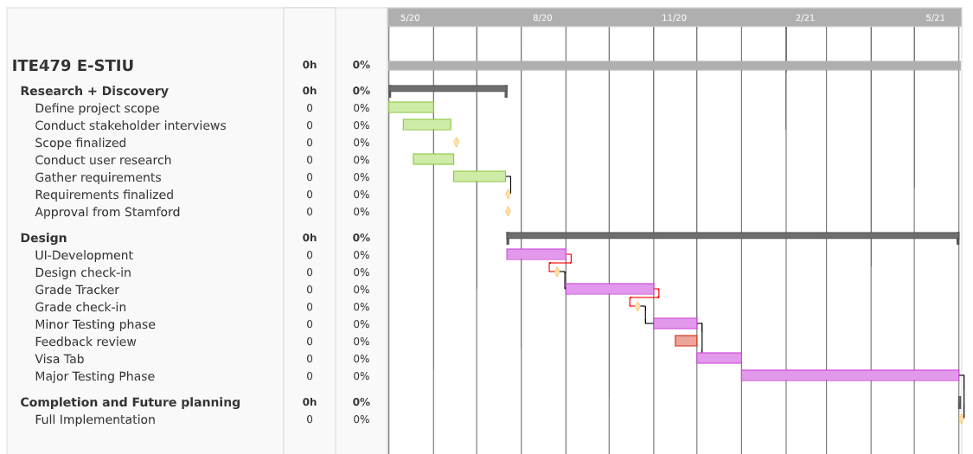

**Project Budget**

Calculated through professional venture capital institutions, the project is budgeted at $20000, of which the human cost $1000, costs and water and electricity fee$ 0 (Stamford international university provides site), to buy $500 of fixed assets, research and development costs 3500 dollars, publicity costs $1000 equipment maintenance fee $1000, Internet use and software cost $500, other costs $500 and $2000 as insurance.

|  |  |  |  |  |  |  |
| --- | --- | --- | --- | --- | --- | --- |
| E-STIU | **#Units/Hrs.** | **Cost/Unit/Hr.** | **Subtotals** | **WBS Level 2 Totals** | **% of totals** | **Contingency plan** |
| **WBS Items** |  |  |  |  |  |  |
| 1. **Complete approval** |  |  |  | **$2000** | **20%** | **20%**  **($4000)** |
| * Stakeholder Approval | **8** | **$22.5** | **$180**  **(9%)** |  |  | **$360**  **(9%)** |
| * Client Approval | **4** | **$30** | **$120**  **(6%)** |  |  | **$240**  **(6%)** |
| * Sponsor Approval | **6** | **$16.67** | **$100**  **(5%)** |  |  | **$200**  **(5%)** |
| 1. **Resource Collection** |  |  |  | **$3000** | **30%** | **30%**  **($6000)** |
| * Application architecture, Database models and Process models. | **6** | **$30** | **$180**  **(6%)** |  |  | **$360**  **(6%)** |
| * Essential funding | **10** | **$36** | **$360**  **(12%)** |  |  | **$720**  **(12%)** |
| * Hiring Programmers. | **10** | **$36** | **$360**  **(12%)** |  |  | **$720**  **(12%)** |
| 1. **Program completion + testing** |  |  |  | **$4500** | **45%** | **45%**  **($9000)** |
| * Program development.   i.e. Implement code, control systems. | **12** | **$48.225** | **$578.7**  **(12.86%)** |  |  | **$1157.4**  **(12.86%)** |
| * Front end and back end programming. | **12** | **$48.225** | **$578.7**  **(12.86%)** |  |  | **$1157.4**  **(12.86%)** |
| * System testing | **9** | **$32.15** | **$289.35**  **(6.43%)** |  |  | **$578.7**  **(6.43%)** |
| * UI & Code Development | **12** | **$48.225** | **$578.7**  **(12.86%)** |  |  | **$1157.4**  **(12.86%)** |
| 1. **Deployment at Facility** |  |  |  | **$500** | **5%** | **5%**  **($1000)** |
| * Production, Data Migration and Operations Switch Over | **10** | **$30** | **$300**  **(3%)** |  |  | **$600**  **(3%)** |
| * Documentation and Training | **8** | **$25** | **$200**  **(2%)** |  |  | **$400**  **(2%)** |
| **Total project estimate** |  |  |  | **$10,000** | **100%** | **$20,000** |

**Constraints, Assumptions, Risks and Dependencies**

|  |  |
| --- | --- |
| Constraints | Password limitation, Internet connection, Data storage |
| Assumptions | Fully functional, Easy to access/use, Understandable for all ages |
| Risks | Information leaks, System malfunction, |
| Dependencies | Internet opinion, University usage, Programmers/Coders/App developers, Feedback, |

**SWOT**

|  |  |
| --- | --- |
| Strengths | -Easy use  -Easy communication to students and teachers  -For students and teachers only  -Free  -Combines both the websites into one app  -Can be used on any platform (Except Gaming consoles) |
| Weakness | -Free  -For students and teachers only  -Needs a constant internet connection  -Possibility of crashes |
| Opportunity | -Can be developed further  -Can use the app to connect to other universities that are partnered to Stamford |
| Threats | -Possibility of Security issues   * Encryption failure if consumer and enterprise devices do not have encryption enabled, then hackers may hack personal plain data. ​​ * Setting of strong or weak passwords and its maintenance depends on users, e.g. if password is related to personal information, then can be hacked. ​​ * If account is hacked the hacker may be able to change personal information which will mess with the students or staff.​ * Hacker may cause server issues example: Server crash, Lag, or shutdown. |

**Application Draft**

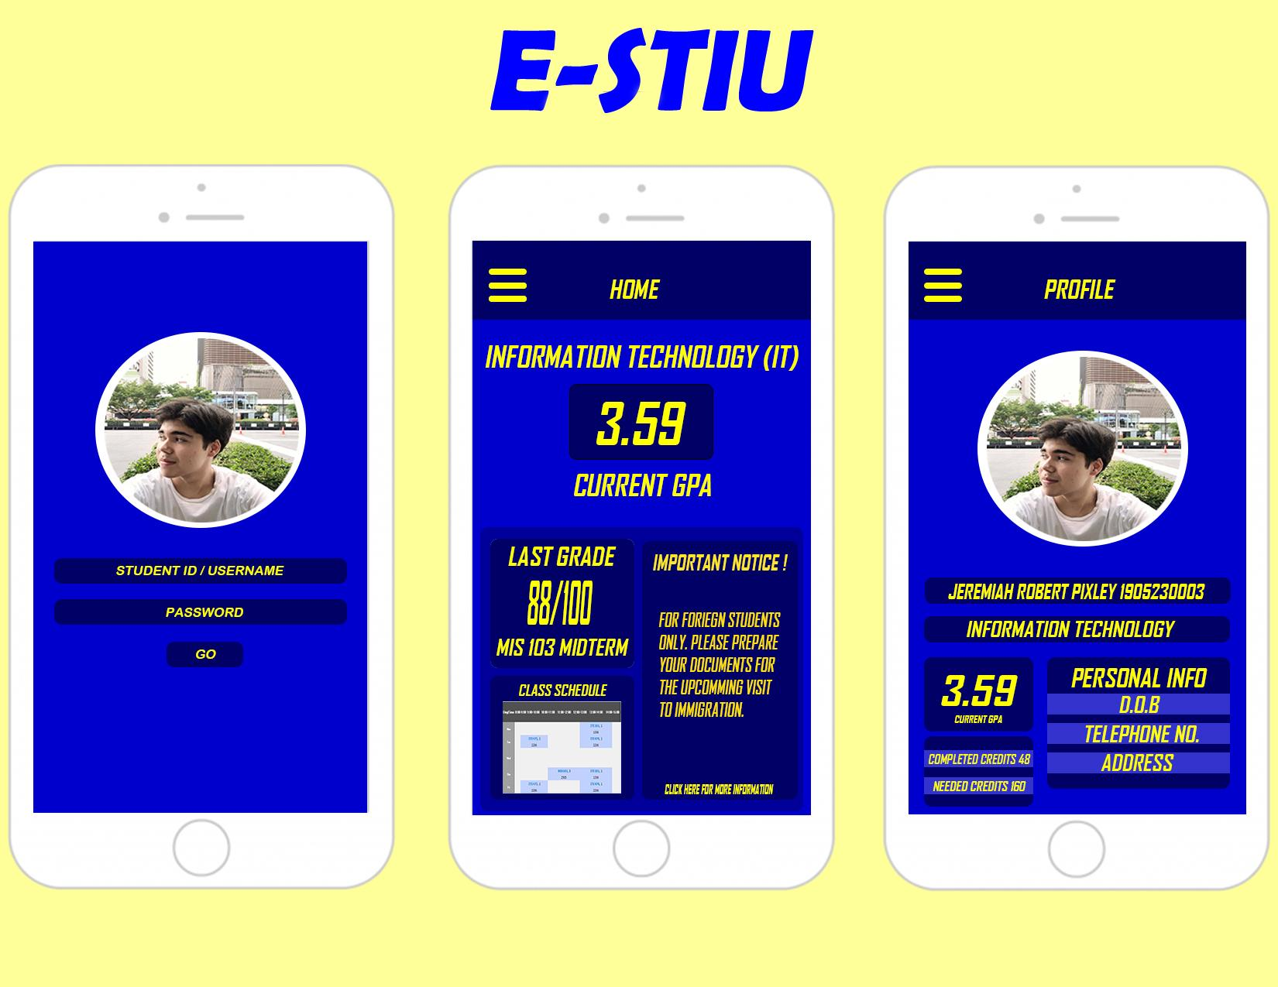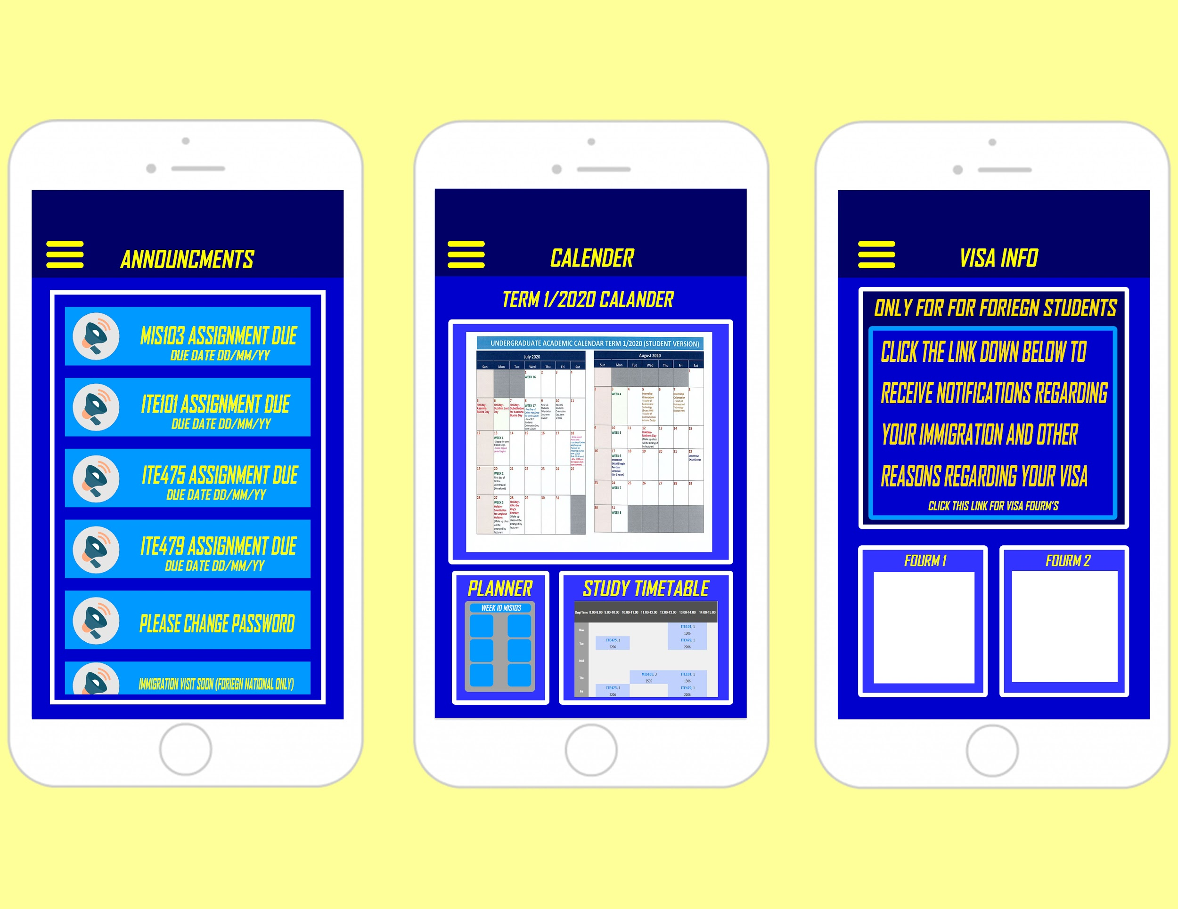

**E-STIU WBS**

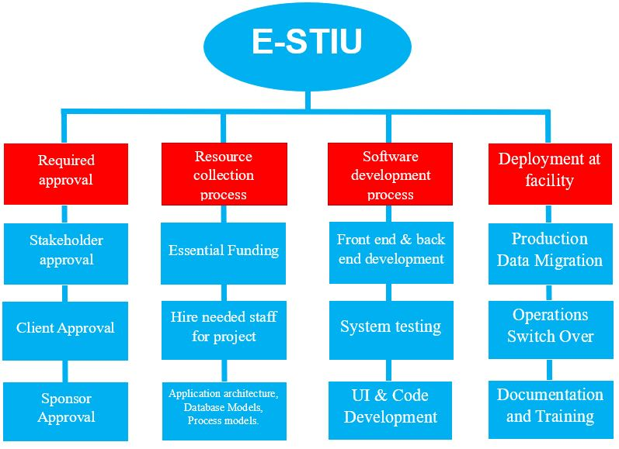

**Scorecard**

